* **GROUP PROJECT I**

CST 291-2

**FINAL REPORT**

PRIVATE MEDICAL CENTER KALUTARA

**Group No: 03**

Computer Science and Technology Degree Program

Department of Computer Science and Informatics

Uva Wellassa University

March 2020

# Declaration

We do hereby declare that the work reported in this report was exclusively carried out by us under the supervision of Mr. S.T.C.I. Wimaladharma. It describes the results of our own independent work except where due reference has been made in the text.

Date: …………………………

Signatures of the Candidates:

|  |  |  |
| --- | --- | --- |
| **Name** | **Registration Number** | **Signature** |
| H.A.B.B. Perera | UWU/CST/17/041 |  |
| H.M.D.P. Herath | UWU/CST/17/023 |  |
| M.K. Udara | UWU/CST/17/061 |  |
| I.K.G. Iddamalgoda | UWU/CST/17/025 |  |

I endorse the declaration by the candidates: ………………………………

Date: …………………..

…………………………

Supervisor

Mr. S.T.C.I. Wimaladharma

Department of Computer Science and Informatics

Faculty of Applied Sciences

# Acknowledgement

# Table of Contents

Declaration ii

Acknowledgement iii

Table of Contents iv

List of Figures v

List of Tables vi

Chapter 1: Introduction 1

1.1 Project Description 1

1.2 Background 1

1.3 Problem 2

1.4 Proposed Solutions and Significance of Study 2

1.5 Objectives 3

Chapter 2: Requirements Identification 4

2.1 Functional and Non-functional Requirements 4

5. The system should be able to access via mobile phones, tablets and laptops also. 5

2.2 User levels, User roles 6

2.3 System Requirements (Minimum Requirements) 7

Chapter 3: Project Design 8

3.1 Data Design 8

3.2 Process Design 8

3.3 User Interface Design 8

Chapter 4: Project Development 9

4.1 Methodology 9

Chapter 5: Testing and Evaluation 10

5.1 Testing Methodologies 10

5.2 Performance Evaluation 10

Chapter 6: Conclusion and Future Works 11

6.1 Conclusion 11

6.2 Future Enhancements 11

References 12

Appendixes 13

Group Details 14

# List of Figures

# List of Tables

# Chapter 1: Introduction

## 1.1 Project Description

* The Private Medical Center website includes user registration, online channeling, maintain patient History records and many more options. The Website has the facility to give a unique Registration Number for every patient and stores the details of every patient and find from Registration Number. This project is powerful, flexible, save time and easy to use and is designed and developed to deliver real conceivable benefits to patients and doctors.

## 1.2 Background

* Medical Centers always deals with life and health of their patients. In the present days most of the people are busy with their day to day life. Every minute is valuable for everyone. So people don’t like to waste their valuable time. Most of the People come forward with new technologies. So the private medical center website is solution for all these.
* The patient can register through website and channel the doctor online for the treatments. This website System reduces amount of paper works and manual data entry and also save the time. The doctor can know all about the patient details (Personal details, History records) from this and it is easy to give the correct medicine for future. When doctor enter the medicine to the prescription, the quantity is checked and if it is not available it is displayed. The Administrator can update the medicine inventory stock. The prescription copy is gone to the pharmacist to prepare medicine and final bill is calculated and it goes to cashier for payments.
* So, in overall about this website is a solution to many problems that we face in medical center and it save lots of time and reduce paper works.

## 1.3 Problem

* In generally a medical center has paper based documents. That documents are hard to maintain and can be misplace.
* It is easy to give medicines for the patient when doctor knows about their history. If the patient has no any documents about their past doctor cannot get it from them.
* Sometimes people have not enough time to go to a medical center and channel a doctor for their needs because people are busy with their day to day lives. And sometimes when channeling it will get more time.
* When manually calculate the bill, it will take some time and the accuracy will be low.
* We do not have any option to know about the dates and the availability of the doctor and also doctors have no option to know about the patient list on a particular day.
* We do not have any option to know if the doctor cannot come on particular day or if the medical center is closed for some unavoidable reasons.
* There is a possibility to make some mistakes when the pharmacist read the prescription which is written by the doctor.

## 1.4 Proposed Solutions and Significance of Study

* We hope to use a user registration and patient history maintain option to maintain a user account and patient history through a database, so we can reduce the paper works.
* We have decided to use an appoint option which can make appointments through the website. So we can save the time.
* To calculate the bill of the particular patient with accurately, we have included the billing option.
* Patient can check the availability of doctors and also doctor can check the patient list on particular day through the website from user view option.
* We have decided to use an email option to inform the patient about the absence of the doctor and if the medical center is closed for an unavoidable reason. (We decided to send mail to the user before three hours from the appointment time.)
* We provide a facility to send prescription belongs to the particular patient through website system.

## 1.5 Objectives

* To reduce paper work.
* To provide trustable and confidential service to the patient.
* To provide a service to easily handle the patient details.
* To develop an efficient system to replace the manual system.
* To reduce the delay to get medicine from the pharmacy to the patient.

# Chapter 2: Requirements Identification

## 2.1 Functional and Non-functional Requirements

**Functional Requirements**

**1. User registration**

* In this process user must be able to submit a valid email address and username.
* The user must be able to submit basic information in the registration process.
* When submit information the system must be able to send mail to account is created. When creating account automatically add the id.
* When login, if user name or password incorrect, the system must be able to shows it as an unsuccessful attempt and also check the other validations.

**2. Appointment option**

* Patient must be able to reserve a doctor from anywhere through website.
* Patient must be able registered for the medical center for online channeling.

**3. Patient history maintain**

* The system must be able to store all the details of the patient (Treatments and medicines).

**4. Bill calculating**

* The bill must be able to calculate automatically and send it to the cashier.

**5. User views**

* Patient must be able to check doctors’ availability for each day.
* Doctor must be able to check the patient list for each day.
* Pharmacist must be able to check the prescription belongs to each patient.

**6. Search option**

* Doctor and Pharmacist must be able to search patient by their username/first name/last name or user ID.

**7. Email option**

* When reserve the doctor, the system must be able to send an email to patients’ email address.
* When submit information the system must be able to send mail to account is created and show details.
* If the reservation is cancelled, the system must be able to send an email to patients’ email address.

**8. Delete option / Remove user**

* Administrator must be able to delete patient history.
* Administrator must be able to delete or remove accounts.

**9. Password reset option through email.**

## 

**Non – Functional Requirements**

1. Performance

* The system database should be accommodating high number of users without any fault.
* System should be accessed quickly.

2. Security

* Users can just read information but they cannot edit or modify anything except their personal details.

3. The system should be able to design in a user friendly environment.

4. The system should be maintainable.

## 5. The system should be able to access via mobile phones, tablets and laptops also.

## 2.2 User levels, User roles

|  |  |
| --- | --- |
| **User Levels** | **User Roles** |
| Public user | * This account does not have any special privileges. * They can reserve a doctor as they wish. * He/she can create an account online. * He/she can view their treatment history, profile, reservations. * Get the details about available doctors for each day. |
| Doctor | * Doctor is the person who is diagnosing the patient and prescribes medicines. * He can check the patient’s history. * View number of appointments. * Cancel appointments. |
| Pharmacist | * Pharmacist is the person who gives the medicines to the patient as the doctor prescribed and he/she sends the details to cashier. * Can view the patients’ profile. |
| Cashier / Receptionist | * When a patient comes to get treatments, give the printed appointment confirmation sheet. * After receiving the details which send by pharmacist, submit it to calculate the bill. |
| Administrator | * This account has the highest privilege. * Administrator is the person who manages all the user accounts. |

## 2.3 System Requirements (Minimum Requirements)

**Software Requirements:**

* MySQL and WAMP Server
* Stands for "Windows, Apache, MySQL, and PHP." WAMP is a variation of LAMP for Windows systems and is often installed as a software bundle (Apache, MySQL, and PHP). It is often used for web development and internal testing, but may also be used to serve live websites.
* PHP
* Stands for "Hypertext Preprocessor." ... PHP is an HTML-embedded Web scripting language. This means PHP code can be inserted into the HTML of a Web page. When a PHP page is accessed, the PHP code is read or "parsed" by the server the page resides on.
* Visual Studio Code
* Visual Studio Code is a code editor redefined and optimized for building and debugging modern web and cloud applications
* Web browser

**Hardware Requirements:**

* Internet connection
* Laptop / Desktop computer or Mobile device
* Intel core i3 or higher
* 4GB RAM or higher
* 100GB Hard Disk or higher
* Ethernet port or Wi-Fi adapter
* Key board and mouse

**Technologies:**

* HTML 5
* CSS 4
* Bootstrap 4.1.3
* PHP 7.0.10
* MySQL 5.7.14
* HTTP
* Laravel

# Chapter 3: Project Design

## 3.1 Data Design

## 3.2 Process Design

**Use-Case Diagram**

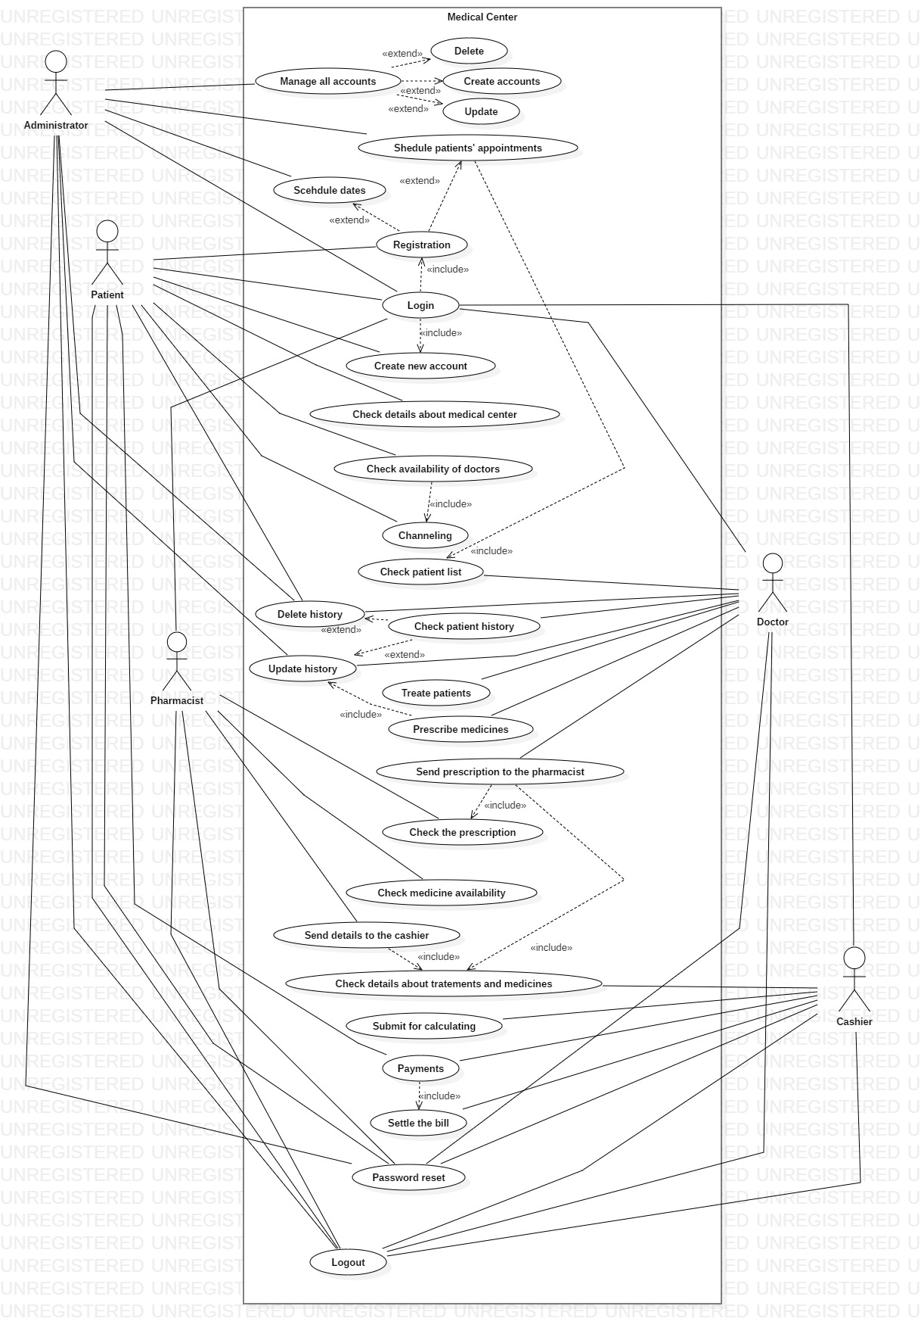

**Class Diagram**

**Activity Diagram**

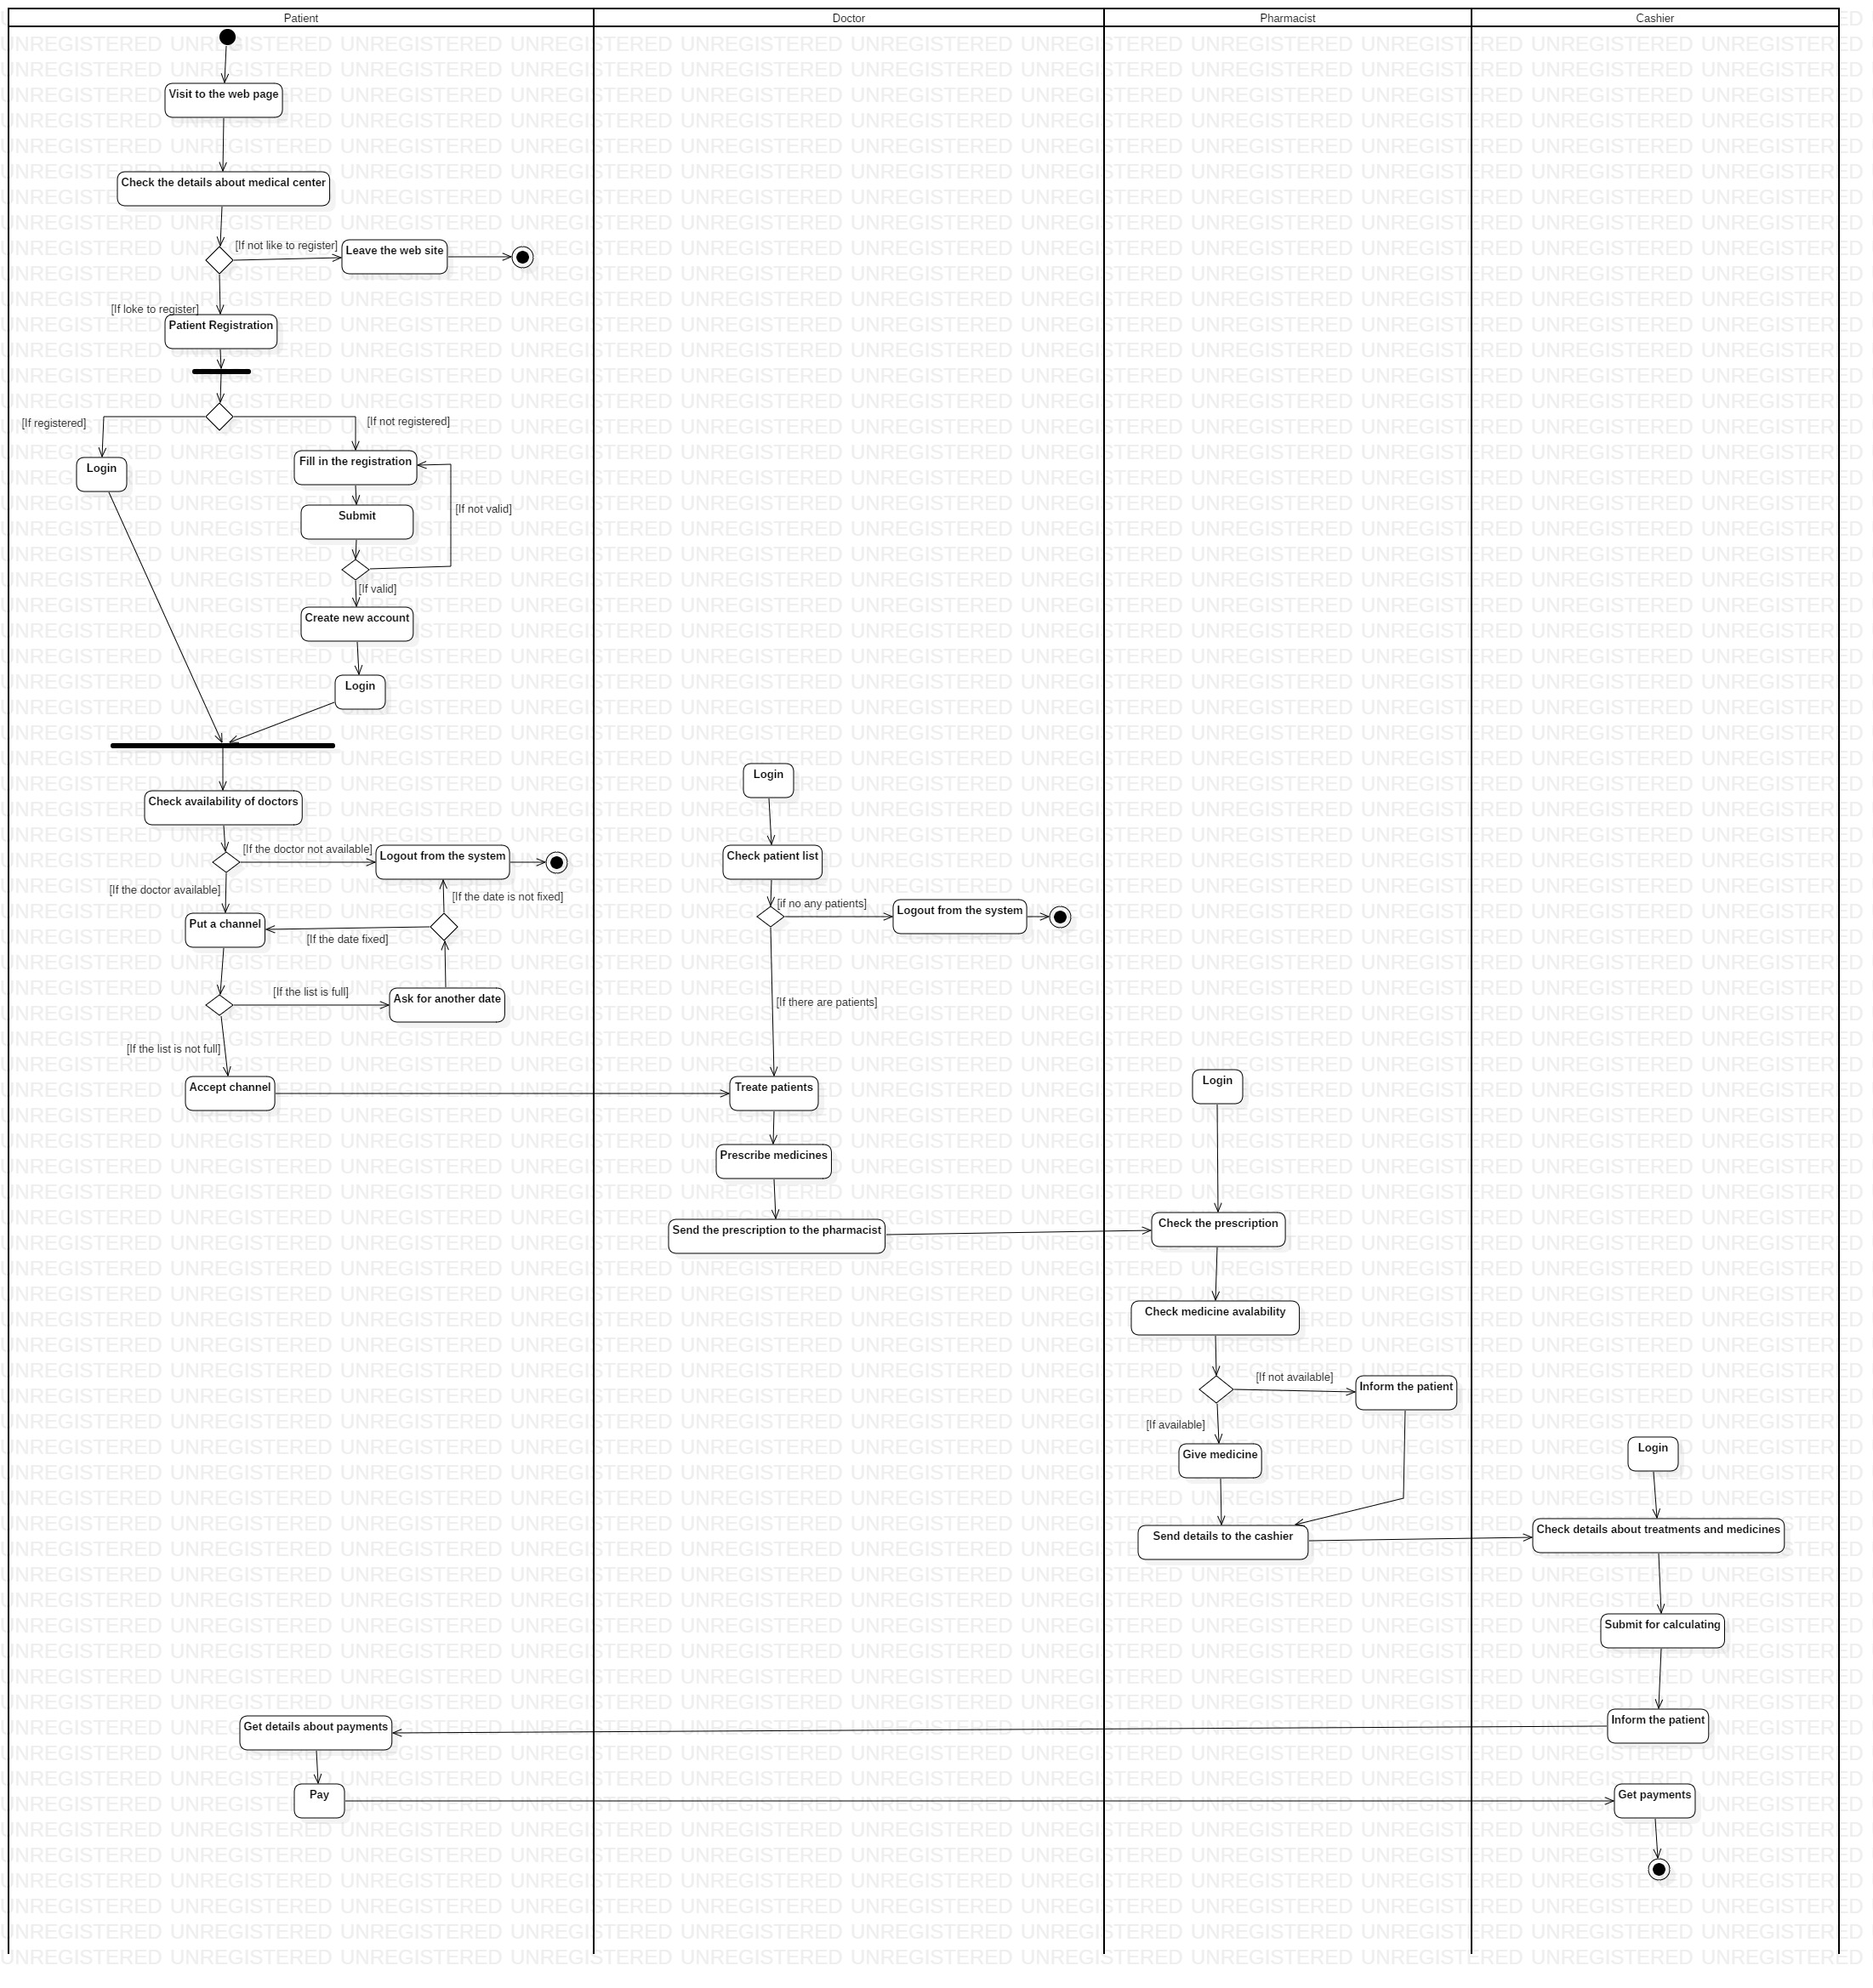

## 3.3 User Interface Design

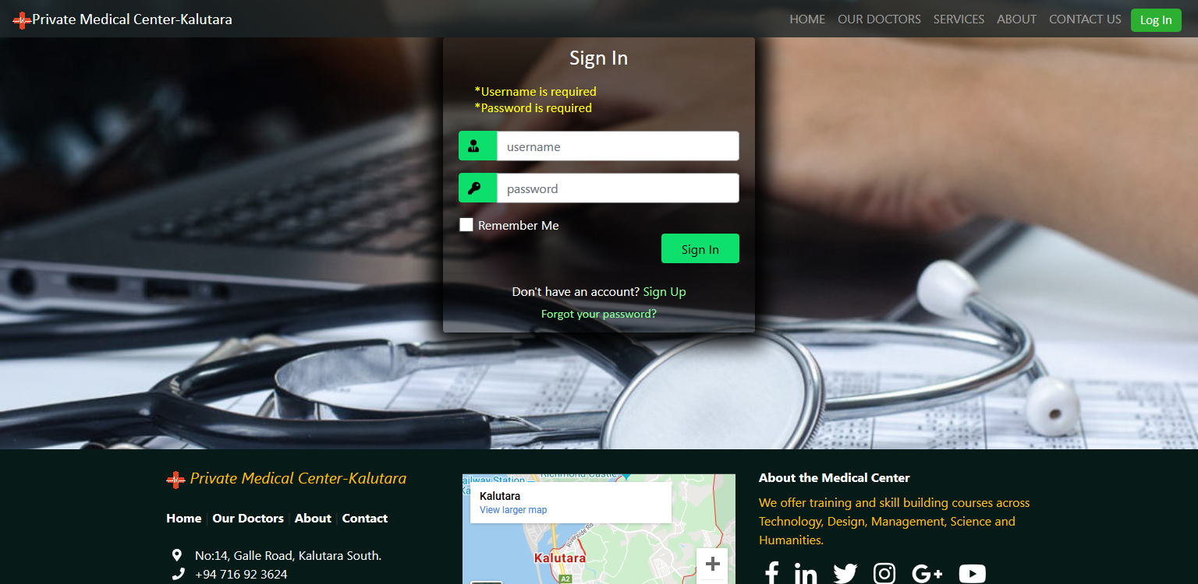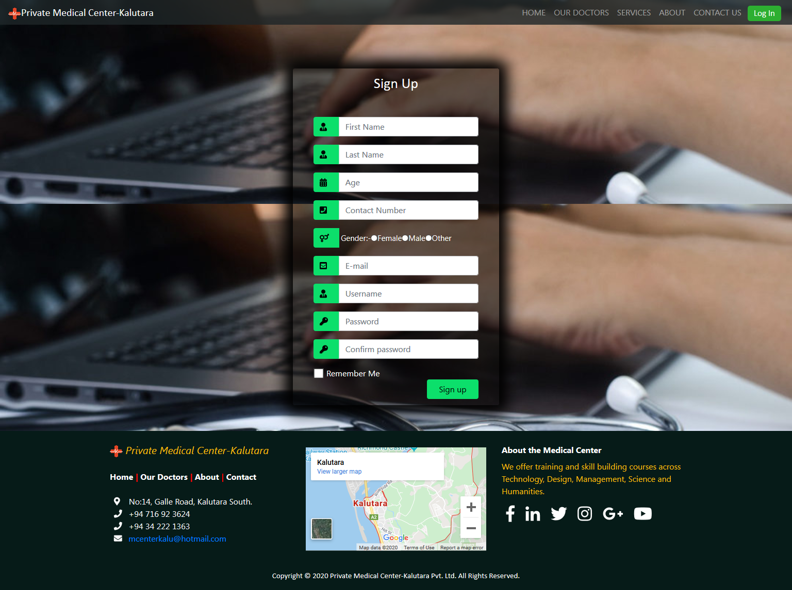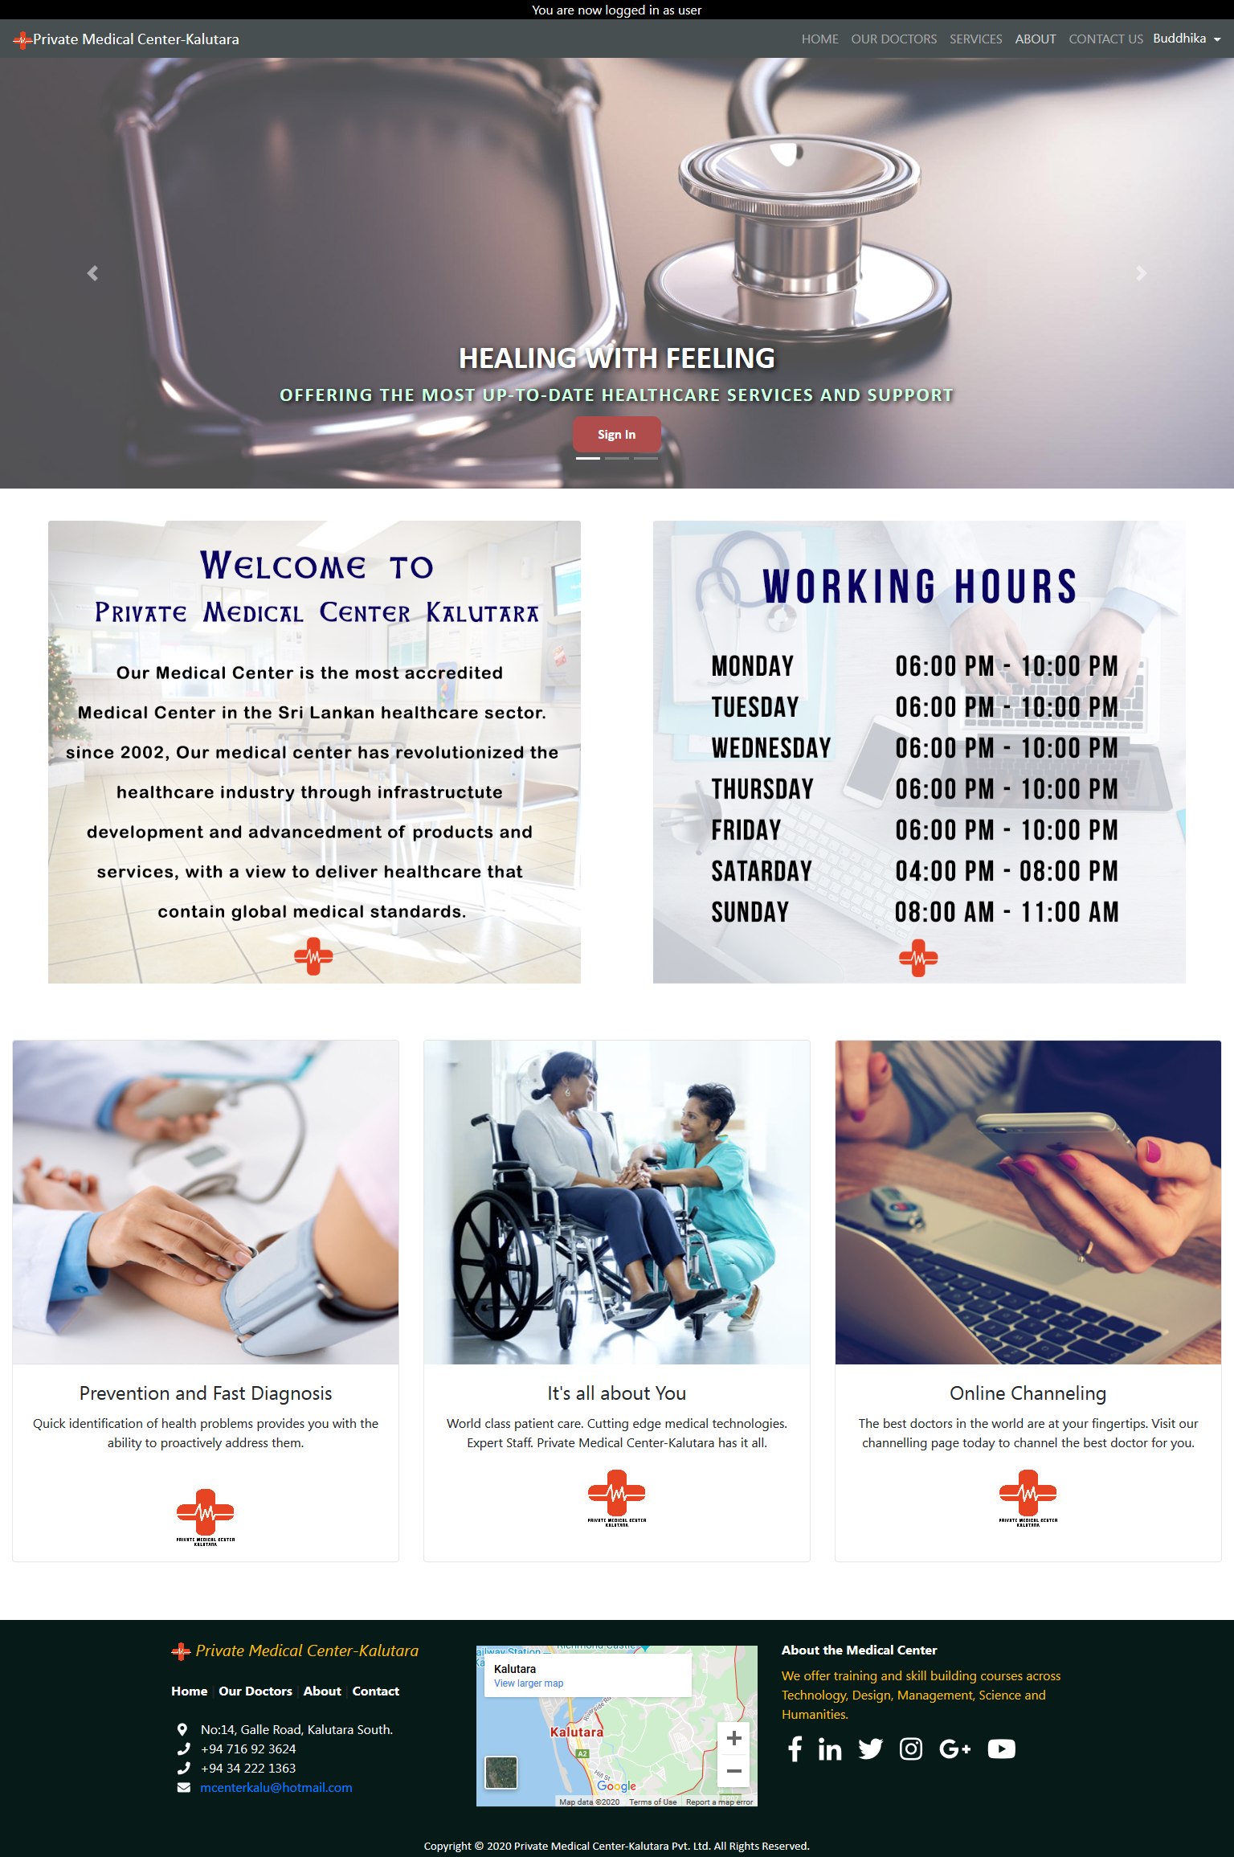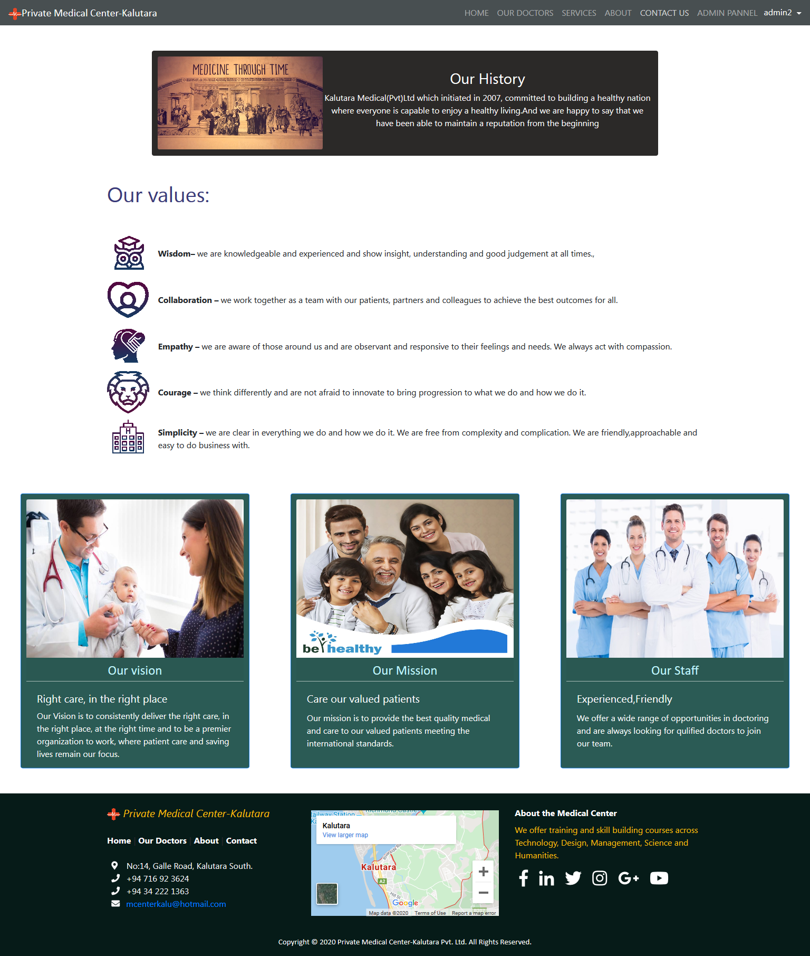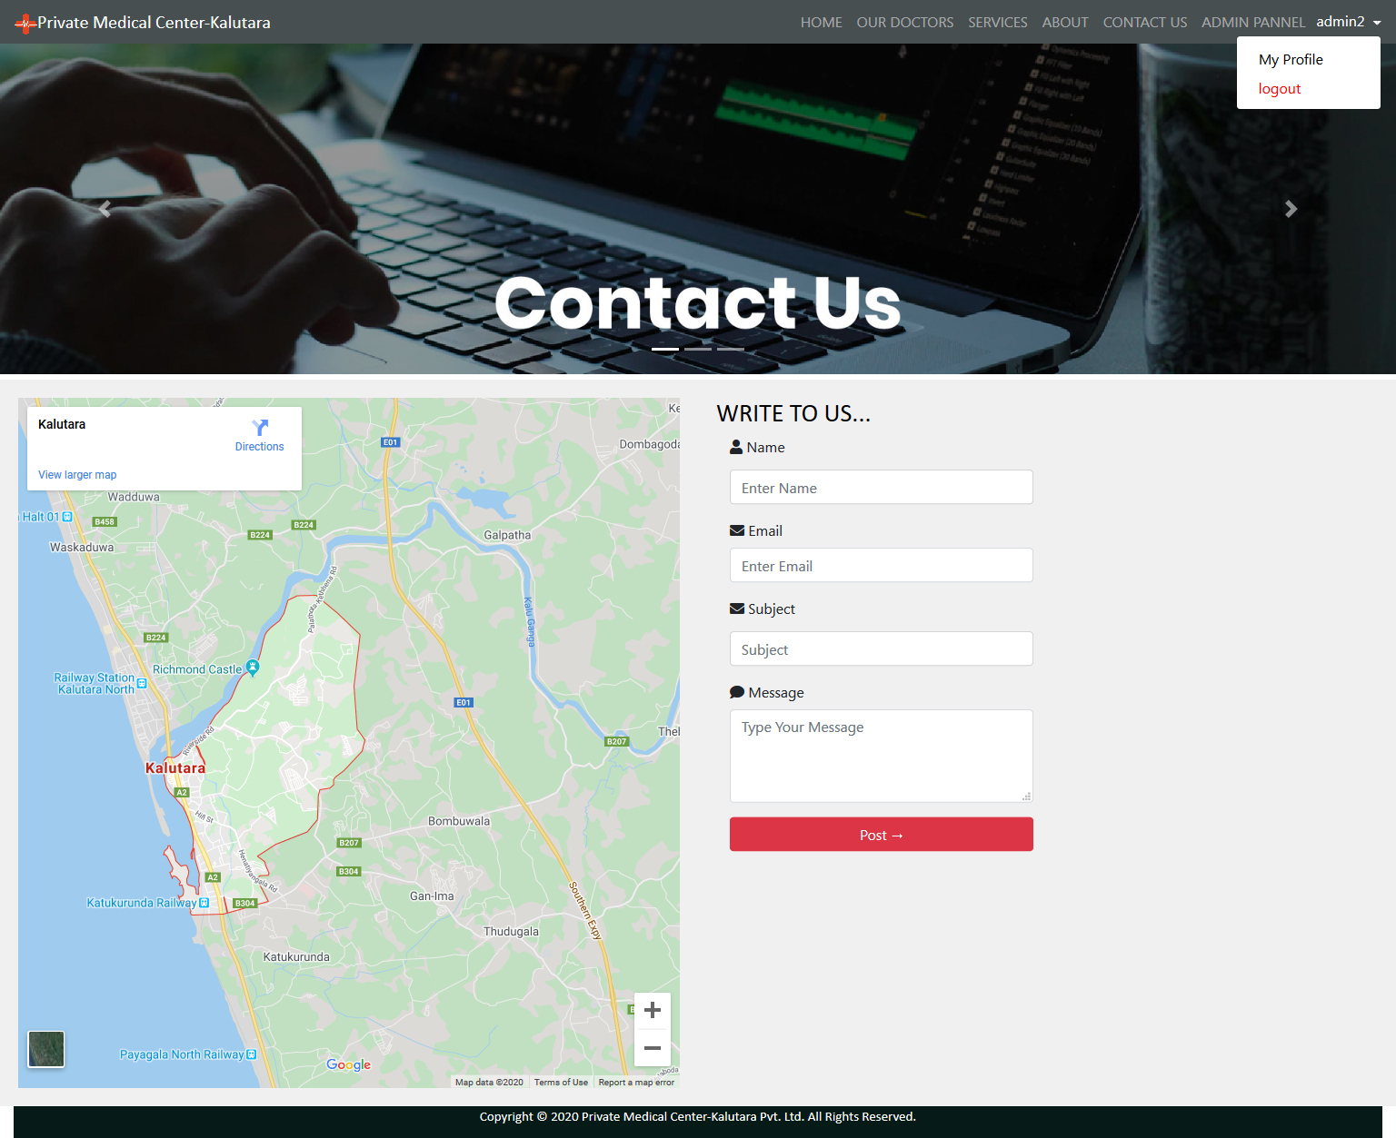

**Responsive view**

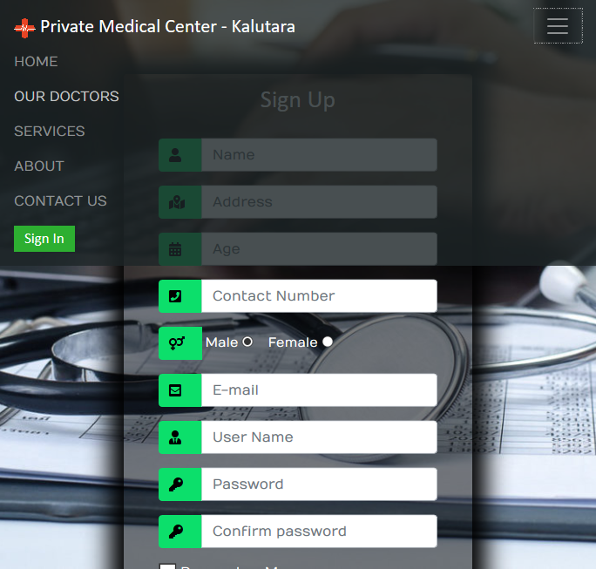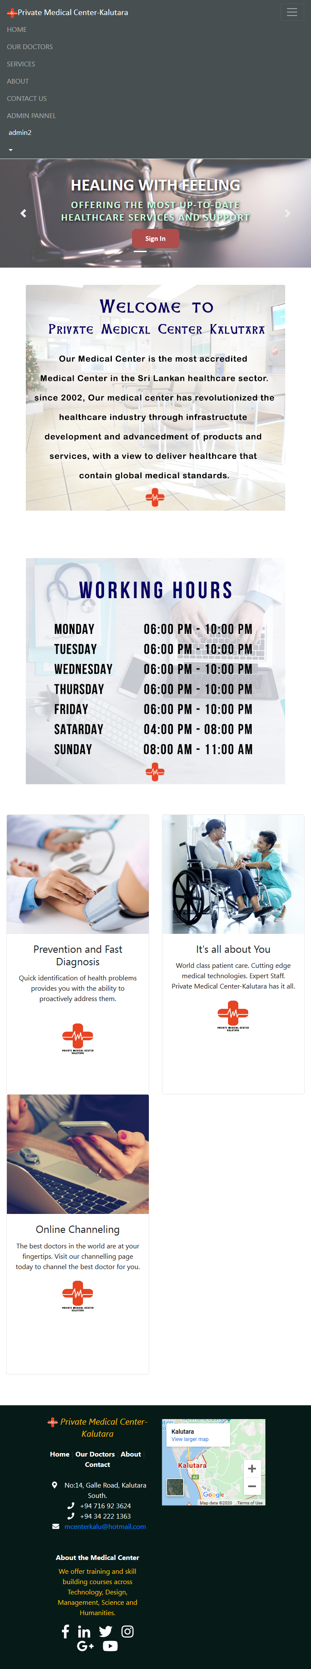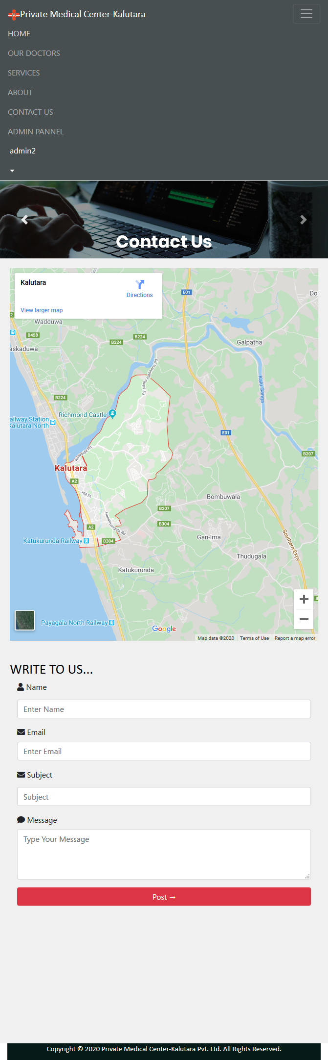

# Chapter 4: Project Development

## 4.1 Methodology

**Incremental Development**

* In our System the requirements are rapidly changing and requirements are not totally fixed. While developing this system we have to face those things. So we want a methodology, which facilitate to accommodate those changes. Therefore, we selected the incremental development process to develop this web system.
* Incremental Model is a process of software development where requirements are broken down into multiple standalone modules of software development cycle. Incremental development is done in steps from analysis design, implementation, testing/verification, maintenance. The increments are priorities and the highest priority requirements are including in early increments. In this process we can have rapid feedback across activities from the customer. With using this Methodology, we can develop the system according to changing customer requirements.
* We hope to develop our system in two or more phases. We decided to develop login system, view option, appointment option, inventory stock maintain option, patient history option and the database design and interface (front-end) designing also the part of the phase one.
* Then in phase two we consider about the search option, print option, send mail option and password reset options are the phase two developing requirements and also we hope to consider about the all other functional and nun functional requirements in this phase two. In this phase also we develop the rest of the interface.
* After finishing this two or more phases combined together. Then we implement and test the website system with and validate it and after that the final documentation will be given to the customer.

# Chapter 5: Testing and Evaluation

## 5.1 Testing Methodologies

## 5.2 Performance Evaluation

# Chapter 6: Conclusion and Future Works

## 6.1 Conclusion

## 6.2 Future Enhancements

# References

* W3schools (2018). W3schools. Available at: https://www.w3schools.com [Accessed 01 September 2018]
* Sisson, T. (2018) PHP mail() Function Code to Send Emails from a Form. Available at: https://www.inmotionhosting.com/support/website/sending-email-from-site/using-the-php-mail-function-to-send-emails

# Appendixes

# Group Details

**GROUP NO: 03**

**Group Members**

|  |  |  |  |
| --- | --- | --- | --- |
| **Registration Number** | **Name** | **E – mail** | **Contact Number** |
| UWU/CST/17/041 | H.A.B.B. Perera | [buddhikaperera95@gmail.com](mailto:buddhikaperera95@gmail.com) | 0716923624 |
| UWU/CST/17/023 | H.M.D.P. Herath | [duliherath70@gmail.com](mailto:duliherath70@gmail.com) | 0770570313 |
| UWU/CST/17/061 | M.K. Udara | [kalaniudara1995@gmail.com](mailto:kalaniudara1995@gmail.com) | 0770289720 |
| UWU/CST/17/025 | I.K.G. Iddamalgoda | [kavi.gayamini95@gmail.com](mailto:kavi.gayamini95@gmail.com) | 0713344084 |

**Supervisor**

|  |  |  |
| --- | --- | --- |
| **Name** | **E – mail** | **Contact No** |
| Mr. S.T.C.I. Wimaladharma | [stcharitha@gmail.com](mailto:stcharitha@gmail.com) | 0718318249 |